|  |
| --- |
| psqBahrain Polytechnic |
| Unix Systems |
| Lab Session 5 |
|  |
|  |
|  |

|  |
| --- |
|  |

# Lab session 5 – Process Management

## Introduction

The lab work consists oftheory and practical tasks. All answers to tasks should be submitted in a text document, uploaded to Moodle.

You must submit the following:

* A single text document, uploaded to Moodle.

**Note: Each Lab session is worth 1% of your final mark**

### **Learning Outcomes Assessed**

The following learning outcomes are being assessed in this lab session:

* Use the command-line on a UNIX system
* Manage a Linux server system (including files, processes, users)

## Lab 5 – Theory questions

Please submit your answers to the following questions on paper.

1. Describe what a ‘process’ is.

2. What impact does a process have on the systems hardware?

3. Explain the following from the screen shot below.

1. PID
2. %CPU
3. %MEM
4. COMMAND

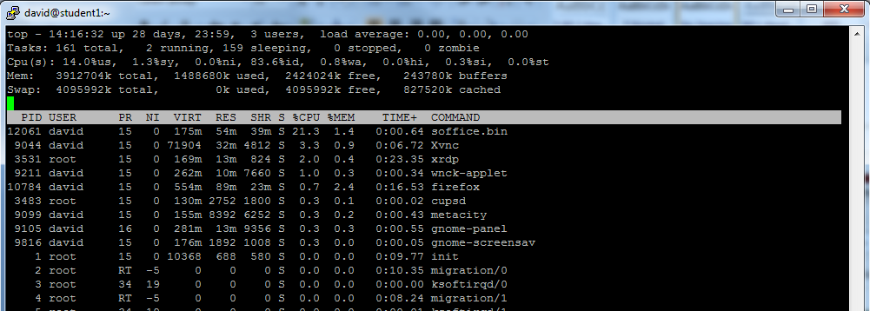

4. If a command was taking a large amount of system resources (memory and processing) and this was causing some system performance issues, what could a system administrator do to solve the problem?

## Lab 5 – Practical tasks - Processes

To complete the practical tasks for lab 5, you will need to run both the command line interface and the Gnome session of Linux (refer to the instructions from lecture 5).

1. Use the appropriate command to:
   1. Check the processes you are running

**Ps**

**Ps -e (To know all the processes running on the system)**

**Ps -f (To see the details of the processes run by the user)**

* 1. Use the appropriate command to check the processor activity in real time (only show 1 iteration)

**Top**

**Top -n1**

The output to ‘1a’ and ‘1b’ should be placed in a text file named ‘lab5_q1.txt’

**Ps > lab5_q1.txt**

**Top -n1 >> lab5_q1.txt**

1. Keep your PuTTY session running and remotely log into Gnome. You should reduce the size of the windows so you can view both Gnome and PuTTY.
   1. Run the same command you used in 1b. This time let it refresh continually
   2. In Gnome, open and run Libre Office Writer and Chromium
   3. Observe what happens with the processes in real time if you type into the document or use the web browser
   4. Confirm that the process state has updated with Libre Office and Chromium. Note, you may have to display all processes (use –help for hints)

The output to ‘2d’ should be placed in a text file named ‘lab5_q2.txt’

**Ps -A > lab5_q2.txt**

1. Using the appropriate command, close down Libre Office (hint – you will need to note the PID).

**Kill -9 PID**

Place the command you used in question 3 into a text file named ‘lab5_q3.txt’

**Vi lab5_q3.txt**

**I used ps to find the process PID and then I used kill -9 to kill the process.**

1. Use the correct command to close down Chromium without knowing the PID. Place the command you used in question 4 into a text file named ‘lab5_q4.txt’

**Vi lab5_q4.txt**

**Kill -9 Chromium**

## Lab 5 – Practical tasks - Pipes

1. Some pipes exercises:

**The function of pipe is to connect more than one command, the output of one command will go into the input of one command**

* 1. What does the command **who | grep A20\*** do?

**Who command shows the users that are logged in**

**Who | grep A20* will display only the student accounts that start with A20**

* 1. Count the number of files in /usr/include (recursively) that name starts with l, end with.h and contain a number

**-R is used when the question says recursively, sub-directory or sub-folder**

**Wc -l is used to count the number of lines**

**Is -lR usr/include | grep ^l*[0-9]*\.h | wc -l**

* 1. The files **F1_drivers_2017** and **F1_drivers_2018** in **/home/lab_files** contains the list of drivers, team and nationalities of F1 drivers in 2017 and 2018. Give a list of French Drivers. Use the command **uniq** to only show each driver once.

**Cat /home/lab_files/F1_drivers_2017 /home/lab_files/F1_drivers_2018 | grep French | sort | uniq**

Place the commands you used and the output of these commands into a text file named ‘lab5_q5.txt’

**Vi lab5_q5.txt**

Find the shortest command to complete parts 6 and 7:

Note that in the command grep:

* . Indicates one character in the pattern
* ^ Indicates the start of the line
* $ Indicates the end of the line

1. Produce a file called lab5_q6.txt that contains the listing of a /etc so that ONLY the directories are listed

**Ls -l | grep ^d > lab5_q6.txt**

1. Find out with one command how many processes are currently running on your system and redirect it to lab5_q7.txt

**Ps -ef | wc -l > lab5_q7.txt**

## Advanced (optional) tasks:

1. Produce a file lab5_qA1.txt that contains a list of all sub-directories in your home directory

**Ls -R > lab5_qA1.txt**

**If sud-directory, sub-folder or recursively is used we need to use ls -R**

1. Identify all files in your home directory which the group has write permission for and redirect it to lab5_qA2.txt

**The writer permission is the 6th one**

**Ls -l | grep ^…..w > lab5_qA2.txt**

1. Produce a file lab5_qA3.txt that contains a sorted list of the unique file extensions in the current directory, with a count of each type

Use the following commands:

* + rev: Reverses the text in the filenames.
  + cut: Cuts the string at the first occurrence of the specified delimiter “.”. Text after this is discarded.
  + mrev: Reverses the remaining text, which is the filename extension.
  + sort: Sorts the list alphabetically.
  + uniq: Counts the number of each unique entry in the list.

**Ls | grep ‘\.’ (will show all files that contain a fullstop)**

**Ls | grep ‘\.’ | rev (will reverse the files names)**

**Ls | grep ‘\.’ | rev | cut -d ‘.’ -f1 (it will separate everything after the dot from the word, and we write f1 to show the things before the . (f2 will show after the.))**

**Ls | grep ‘\.’ | rev | cut -d ‘.’ -f1 | rev | (to reverse the words back to normal)**

**Ls | grep ‘\.’ | rev | cut -d ‘.’ -f1 | rev | sort | (to sort the names alphabetically)**

**Ls | grep ‘\.’ | rev | cut -d ‘.’ -f1 | rev | sort | uniq -c (to show each file type once without duplicates, and we use -c to count how many files exist for each type)**

## Lab5 – What you need to submit

1. Submit your answers to the theory questions on paper to your tutor at the end of the class
2. Submit the following text files, in ONE zip file together, on Moodle:
   1. Lab5_q1.txt
   2. Lab5_q2.txt
   3. Lab5_q3.txt
   4. Lab5_q4.txt
   5. Lab5_q5.txt
   6. Lab5_q6.txt
   7. Lab5_q7.txt

Name the zip file ‘Lab5_*studentID*’.

**Tar cvf lab5_202201043.tar all files**

**Zip lab5_202201043.zip lab5_202201043.tar**

**Open psftp**

**Open student2.bptest.cloud**

**A202201043**

**041112253**

**Lcd C:\Users\USER\Documents**

**Get lab5_202201043.zip**

Connect to Moodle using the standard web browser (<http://www.tinyurl.com/moodlepoly>) or (http://webdev.polytechnic.bh/moodle) and then upload the saved document to the ‘Lab5 file upload’ area in the Unix Systems Moodle course.